**2. ReactJS-HOL**

**Objectives**

* **Explain React components:** A React component is an independent, reusable piece of code that represents a part of a user interface (UI).
* **Identify the differences between components and JavaScript functions:** React components are specialized functions or classes that take properties (props) as input and return React elements that describe what should appear on the screen. Standard JavaScript functions perform specific tasks and return an output.
* **Identify the types of components:** The two main types of components in React are Class Components and Function Components.
* **Explain class component:** Class components are defined using ES6 class syntax, extend React.Component, and have a render() method that returns JSX. They can manage their own state and lifecycle methods.
* **Explain function component:** Function components are defined using a JavaScript function and are simpler to write. With React Hooks, they can also manage state and handle lifecycle events.
* **Define component constructor:** For class components, the constructor() is a special method called when a component is created, used to initialize state and bind event handlers. It's crucial to call
* **Define render() function:** The render() method is the only mandatory method in a class component, responsible for returning the JSX that describes what the component should render. It should be a pure function.

**Student Management Portal**

**Code:**

Home.js

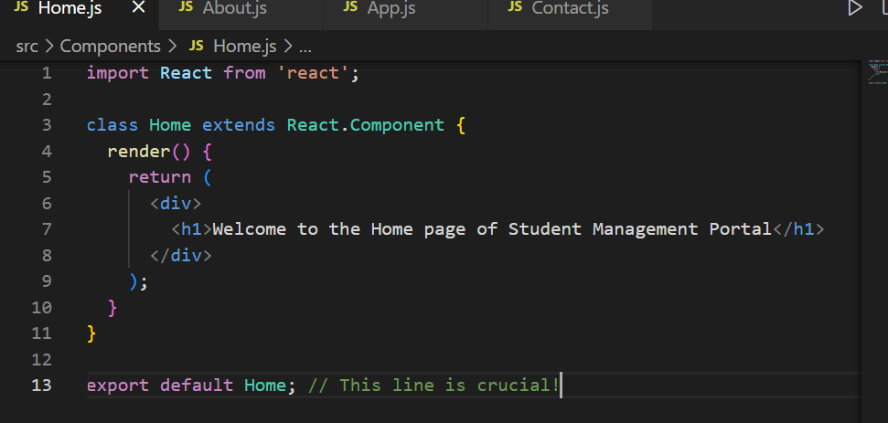

About.js

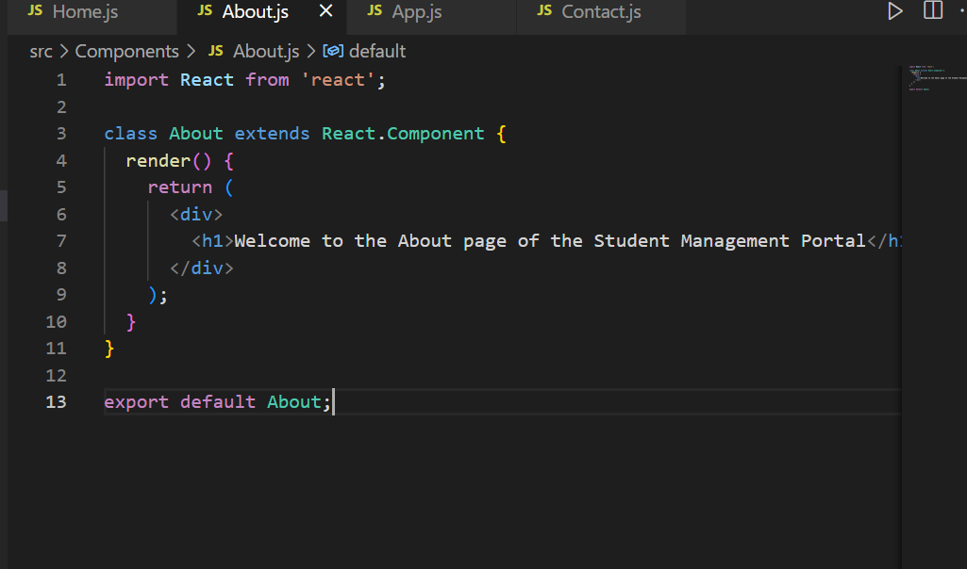

Contact.js

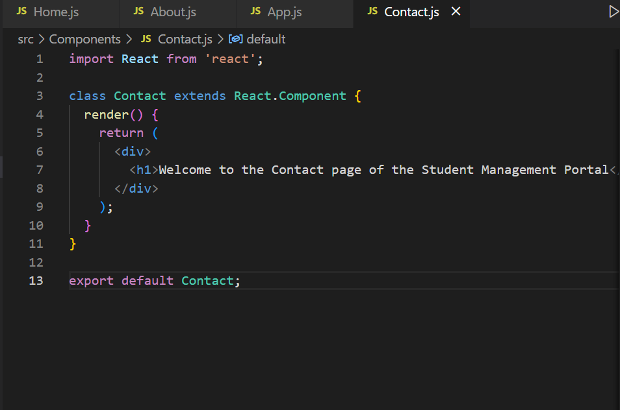

App.js 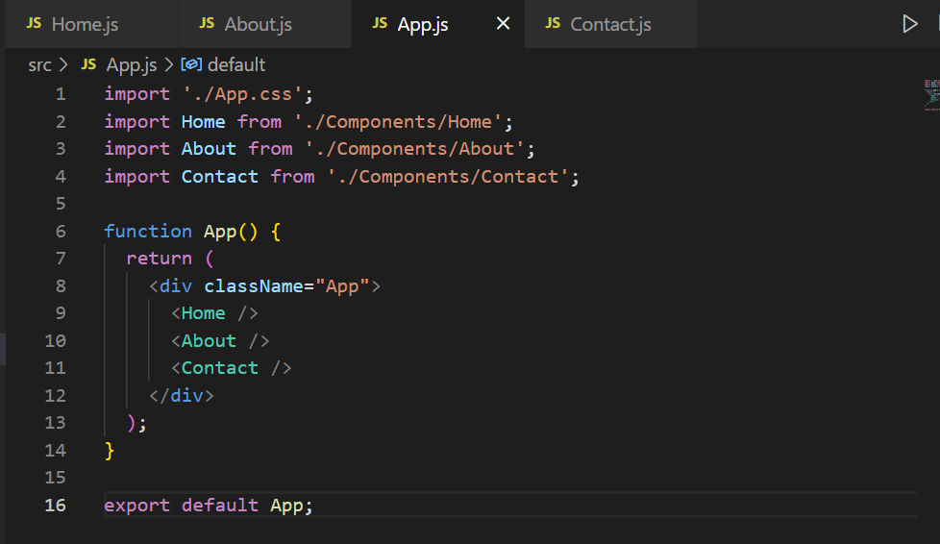

**Output**

